AMERICAN LEGION RIDERS
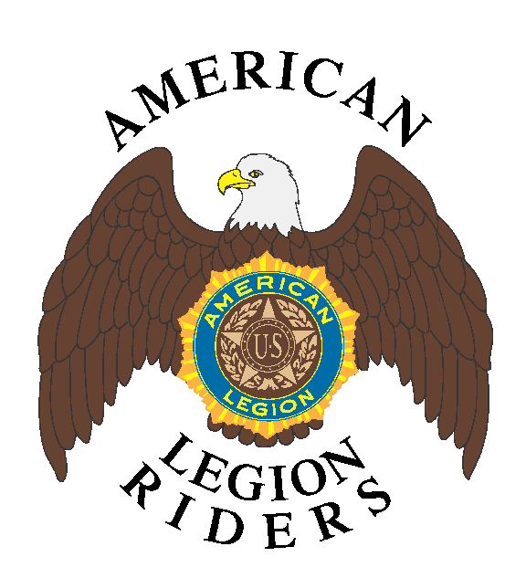

Certificate of Appreciation

This certificate of appreciation is gratefully presented to

In recognition and sincere appreciation of outstanding service
and assistance to the American Legion Riders
which contributed to the advancement of
The American Legion programs and activities dedicated to
God and Country.

Presented by

Department of

This Day of ,

ATTEST:

________________________________________ ________________________________________

